User Story

Program Function:

* Ask for user name, date of birth, and email.
* Update information and display to user.

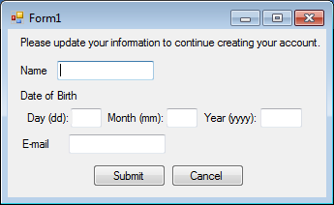

Important Variables:

String name; //Holds name

String email; //Holds email

Int DOBYear, DOBMonth, DOBDay; //Holds DOB values

Int DayChecker; //Holds number of days in the month entered.

The way it is setup:

* Name: Name is taken in as a string.
* Email: email is taken in as a string.
* Date of Birth:
  + These fields get taken in and validated to make sure it is correct
  + The following process is how it checks.

If(int.TryParse(DOBYear))

Check to make sure it is a number from 1930-2016

If No: Throw error

If Yes:

If(int.TryParse(DOBMonth))

Check to make sure it is a number from 1-12

If No: throw error

If Yes:

Daychecker = Function to check days of month()

If(int.TryParse(DOBDay);

Check to make sure it is a number from 1-daychecker.

If NO: Throw error

If Yes:

Print Final message using a function.

\*\*\*If any TryParses fail, it will print out an error.